Doc Name | Mobile App Requirements
Created By | Nilesh Dabhi
Reviewed By | Janvi Soni
Approved By
Date | 23-Sep-2025

Mobile App Requirement Document:

In-Scope (Phase 1 – LMS Mobile App):
- Learner authentication (login/sign-up).
- Access to enrolled programs (dashboard/home screen).
- Access to course/program modules.
- Attendance of live sessions via mobile.
- Viewing upcoming sessions and calendar integration.
- Accessing session recordings.
- Participation in discussion boards.
- Participation in assessments/quizzes.
- Tracking course progress.
- Viewing and sharing earned certificate s.
- Notifications for session reminders, assessments, and other key activities.

Out-of-Scope (for this phase):
- Full website access
- Instructor/admin functionality via mobile app.
- Payment gateway integration.
- Community features beyond disc

Constraints / Considerations
- Technical Dependencies:
  - Do LMSs provide mobile application features?
  - Integration with existing LMS backend and APIs.
  - Video-conferencing platform integration (Zoom) for live sessions.
  - Push notification service setup.
  - Regular maintenance for the mobile app (do we need a team/person dedicated)
- Device Compatibility: iOS & Android (latest 2 OS versions).
- Scalability: Must support concurrent learners without performance issues.
- Phase-wise Rollout: Focus on core LMS functionality first; other features can be added in later phases.
- Security & Privacy: Ensure secure access, user authentication, and data privacy compliance.

Feature Breakdown

1. User Authentication & Access
- Learners must be able to log in securely using their registered credentials.
- On successful login, enrolled courses and programs should be visible on the dashboard/home screen.
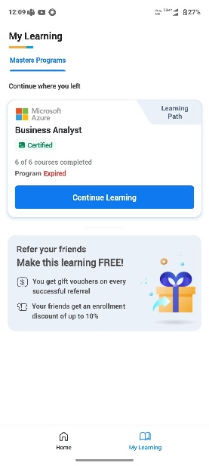
This screenshot is for reference only and has been taken from a competitor's app

2. Course & Program Access
- Learners should be able to view all courses/programs they are enrolled in.
- On selecting a course/program, learners should see the course modules and access their contents.
- Support for both live sessions and self-paced modules.
- 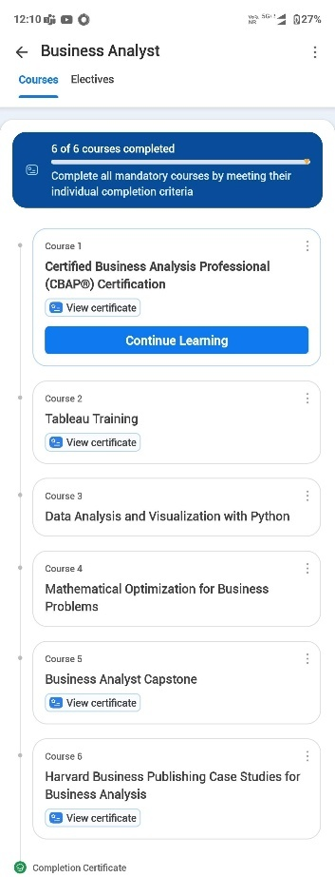
This screenshot is for reference only and has been taken from a competitor's app

3. Live Sessions
- Learners must be able to attend live sessions directly from the mobile app.
- Sessions should integrate with a supported video conferencing tool (Zoom or in-app player).
- Option to join via calendar or session details.
- 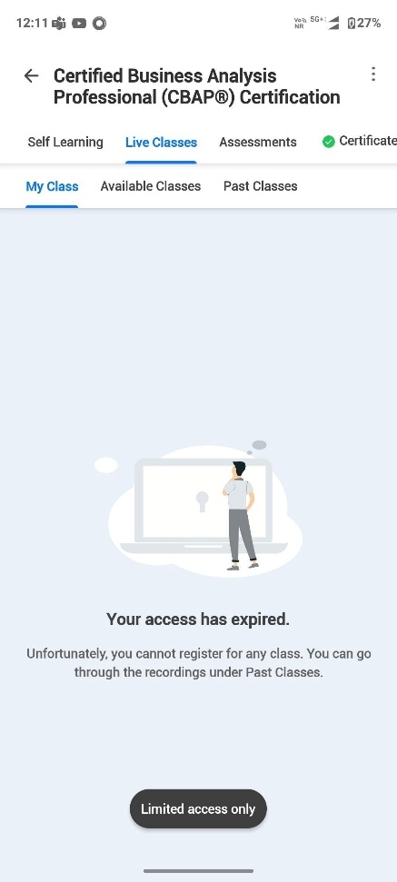
This screenshot is for reference only and has been taken from a competitor's app

4. Calendar & Upcoming Sessions
- Learners should have a calendar view showing all upcoming sessions.
- Session details: date, time, trainer info, session title.
- Reminders & one-click join functionality.
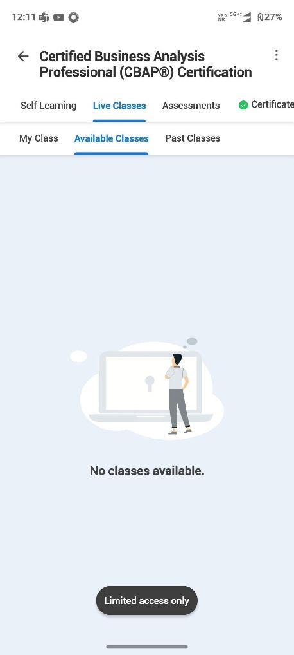
This screenshot is for reference only and has been taken from a competitor's app

5. Session Recordings
- Past session recordings should be available for playback.
- Recordings should be linked to the respective course/session.
- 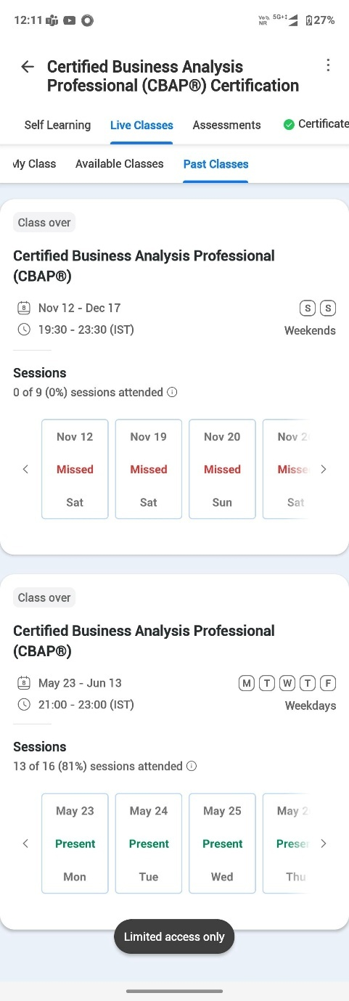
This screenshot is for reference only and has been taken from a competitor's app

6. Content Access (Self-Paced Learning)
- Learners should be able to access self-paced content (videos, documents, quizzes, assignments).
- Navigate between modules/lessons.
- Mark lessons as complete.
- Resume content from the last watched position.
- 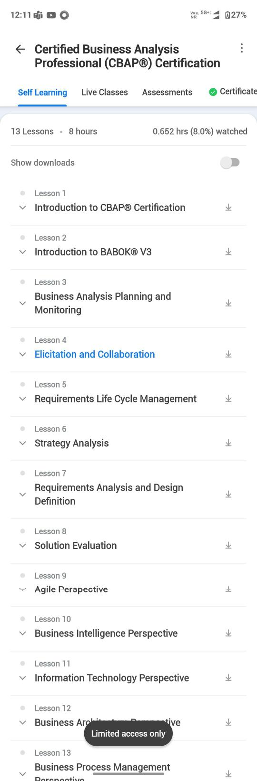
This screenshot is for reference only and has been taken from a competitor's app

7. Assessments
- Learners must be able to attempt assessments via the app.
- Multiple formats supported: quizzes, MCQs, assignments, Kahoot (integration check needed).
- Submit answers directly via the app.
- Notifications for pending or upcoming assessments.

- 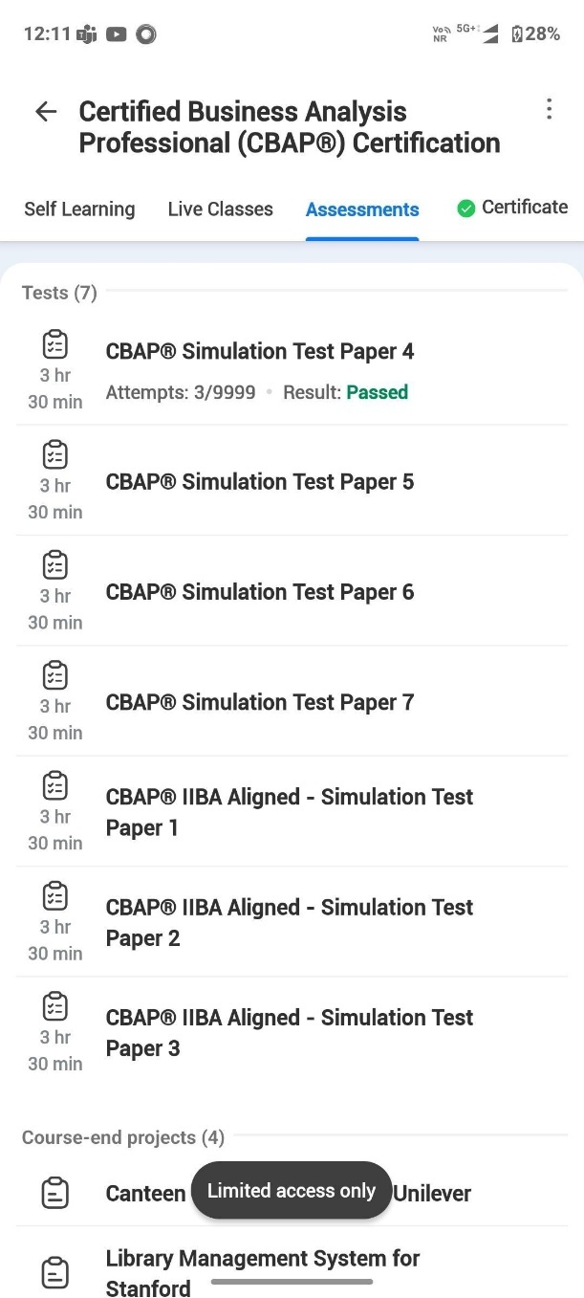
This screenshot is for reference only and has been taken from a competitor's app

8. Discussion Board
- Learners should be able to participate in discussion forums from within the app.
- Features: post, comment, reply, like, and share resources.
- Notifications for replies/mentions.
- Search and filter discussions by topic or keyword.

9. Certificates
- Learners should see all certificates they have earned.
- Learners should be able to download earned certificate in valid formats.
- Ability to share certificates on social media and via email.
- 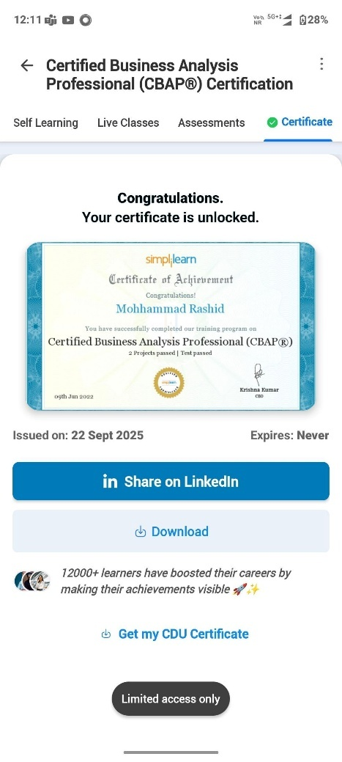
This screenshot is for reference only and has been taken from a competitor's app

10. Progress Tracking
- Learners should have a progress tracker per course/program.
- Show completed modules, ongoing modules, assessment results, and overall completion percentage.
- Visual representation of course completion (percentage progress).
- Track overall progress across multiple courses.
- Highlight incomplete lessons or pending assessments.

11. Notifications
- In-app push notifications for: upcoming sessions, live sessions, assessments, discussion replies, and certificates earned.
- In-app notification centre to view all alerts.

12. Integration with Kahoot (Optional / To be Scoped/phase 2?)
- Assess the feasibility of integrating Kahoot for gamified quizzes and learning.

